PROJECT NAME： GSe Pro 3008 series |  |  |  |  |  |  |  |  | Rev.：1.2
DESCRIPTION: (ref):
GSe Pro 3008 series
2U8-bay RAID subsystem, Generic controller, SATA, Single PSU, Intel Broadwell-DE 4-Core CPU D-1517
2U8-bay RAID subsystem, Generic controller, SATA, Redundant PSU, Intel Broadwell-DE 4-Core CPU D-1517

PRODUCT MANAGER：Glenn.Lee |  |  |  |  | DATE：2017/07/07
MODEL NAME / NUMBER :
GSe Pro 3008 serial models
GSe Pro 3008SP + dual optional host boards (4 in 1, iSCSI 10G (RJ45) , iSCSI 10G SFP+, SAS 12G, iSCSI 1G, Infiniband 56G x 2, iSCSI 40G x 2 , FC16 x2, FC16G x4, SAS 12G JBOD Expansions )
GSe Pro 3008RP + dual optional host boards (4 in 1, iSCSI 10G (RJ45) , iSCSI 10G SFP+, SAS 12G, iSCSI 1G, Infiniband 56G x 2, iSCSI 40G x 2 , FC16 x2, FC16G x4, SAS 12G JBOD Expansions )

APPROVED：
FW PM HW TM FW TM ME TM SW TM
PROJECT ORIGINATOR |  |  |  |  | PM MANAGER
NOTIFY：
SALE |  | SOFTWARE | HARDWARE | MFG. MGR. |  | GEN.MGR.

Change History List
Rev | Update Reason |  |  |  |  |  | Updated Date |  |  | Updated By |  | Approved By
1.0 | New Release |  |  |  |  |  | 2017/06/06 |  |  | Glenn.Lee
1.1 | Update Single PSU models |  |  |  |  |  | 2017/07/07 |  |  | Glenn.Lee
1.2 | Remove Single PSU model |  |  |  |  |  | 2017/10/23 |  |  | Glenn.Lee

Section 1: Overall view for whole product
Category | Functional Specification | Remark
Innovation | First IFT cloud gateway product
EonStor serial models products definition | Per C0 spec., EonStor GS serial models are:  - GSe Pro 3008SP  - GSe Pro 3008RP  EonStor FS C0 MKT document:  - \\server02\Marketing\Product Planning\C0\Unify storage\Cloud Gateway  HDD Bundle policy:  - Any number of "Drive + Plastic Tray"  - HDD types and q’ty are defined by Planning  Cloud Gateway Product feature:  Please follow the latest GS product feature:  Host Board Support types:  GSe Pro 3000 series Performance requirement:  GSe Pro 3000 series JBOD Support Models and Max Drive Policy:  GSe Pro 3000 series JBOD Support Configurations and Max Drive Policy:
  Models | Host board types and ports | Qty per CTRL
  GSe Pro 3000 series | Converged host board (4 in 1) | X 2
  GSe Pro 3000 series | iSCSI 10G (RJ45) x 2 | X 2
  GSe Pro 3000 series | iSCSI 10G SFP+ x 2 | X 2
  GSe Pro 3000 series | SAS 12G x 2 | X 2
  GSe Pro 3000 series | iSCSI 1G x 4 | X 2
  GSe Pro 3000 series | FC16G x 2 | X 2
  GSe Pro 3000 series | FC16G x 4 | X 2
  GSe Pro 3000 series | iSCSI 40G QSFP+ x 2 | X 2
  GSe Pro 3000 series | Infiniband 56G QSFP+ x 2 | X 2
  GSe Pro 3000 series | SAS 12G x 2 for JBOD Expansions | X 1
  Product Family | GSe Pro 3008
  CPU | BDE D-1517
  Drive side interface | SATA 6G
  GSe File read (MB/s) | 400
  GSe File write (MB/s) | 400
  RAID Model Name | Support JBOD Models | Max Drive Number
  GSe Pro 3008 | JB 3012A  JB 3060/3060L | 428 HDD
  RAID Form-factor | Recommended JBOD Configuration | Total Number of Disks
  2U8 | RAID 3U12 x1 + JBOD 3U12 x 14 | 176
  2U8 | RAID 3U12 x1 + JBOD 4U60 x 7 | 428
  GSe Pro 3000 Host board configurations list
  Host Board 1 | Host Board 2
  Converged host board (4 in 1) | None
  iSCSI 10G (RJ45) x 2 | None
  iSCSI 10G SFP+ x 2 | None
  SAS 12G x 2 | None
  iSCSI 1G x 4 | None
  FC16G x 2 | None
  FC16G x 4 | None
  iSCSI 40G QSFP+ x 2 | None
  Infiniband 56G QSFP+ x 2 | None
  Converged host board (4 in 1) | Converged host board (4 in 1)
  iSCSI 10G (RJ45) x 2 | iSCSI 10G (RJ45) x 2
  iSCSI 10G SFP+ x 2 | iSCSI 10G SFP+ x 2
  SAS 12G x 2 | SAS 12G x 2
  iSCSI 1G x 4 | iSCSI 1G x 4
  FC16G x 2 | FC16G x 2
  FC16G x 4 | FC16G x 4
  iSCSI 40G QSFP+ x 2 | iSCSI 40G QSFP+ x 2
  Infiniband 56G QSFP+ x 2 | Infiniband 56G QSFP+ x 2
  iSCSI 10G (RJ45) x 2 | iSCSI 1G x 4
  iSCSI 10G SFP+ x 2 | FC16G x 2
  iSCSI 10G SFP+ x 2 | FC16G x 4
  iSCSI 10G SFP+ x 2 | Converged host board (4 in 1)
  iSCSI 1G x 4 | FC16G x 2
  iSCSI 1G x 4 | Converged host board (4 in 1)
  FC16G x 4 | iSCSI 10G SFP+ x 2
  FC16G x 4 | Converged host board (4 in 1)
  Converged host board (4 in 1) | SAS 12G (for JBOD expansion)
  iSCSI 10G (RJ45) x 2 | SAS 12G (for JBOD expansion)
  iSCSI 10G SFP+ x 2 | SAS 12G (for JBOD expansion)
  SAS 12G x 2 | SAS 12G (for JBOD expansion)
  iSCSI 1G x 4 | SAS 12G (for JBOD expansion)
  FC16G x 2 | SAS 12G (for JBOD expansion)
  FC16G x 4 | SAS 12G (for JBOD expansion)
  iSCSI 40G QSFP+ x 2 | SAS 12G (for JBOD expansion)
  Infiniband 56G QSFP+ x 2 | SAS 12G (for JBOD expansion)
DIMM Configuration Requirements | Default configuration: 4GBx1  Support DDR4 up to 64G (32Gx2)  Optional configurations: 8GB (4GBx 2), 16G (8G x2), 32G (16Gx2), 64G (32Gx2)
Push button requirement | For Reset CTRL to Restore default Status
LCD and LED Requirements | Only support LED PNL;  LED follows ES_LED_FP_v1.22 or later version
HDD Support requirements | Support mixing SATA 3G/6G drives on AVL  Support SATA-SSD (SSD: follow HDD AVL plan)
Form-factor requirements | Follow Enhance 3US and 2US ME design.
RoHS requirement | RoHS complaint is a MUST from development stage
PSU Requirements | For 2U12/3U16 platform: Delta-250W
  RAID Form-factor | Enclosure Name | Controller | PSU | Vendor
  2U8 | 2US | Generic | 250 Watt | Delta
Patent Concern | N.A.
MTBF | Controller: 500,000 hours  Subsystem: 25,000 hours  Power supplies: 250,000 hours  Fans: 500,000 hours
EMC / Safety | Certification product names: should follow IFT business method of CTO  EMC: BSMI, FCC / CE Class B (Class A is Acceptable).  Safety: UL / cUL, CB, and ROSTEST (Russia Certificate)
Env. | Thermal: System working temperature should follow specs.  - Normal Operating: The temperature should be below 40C.  - Abnormal Operating (FANx1 or PSUx1 Failure): The temperature should remain below 40C  - Due to CPU spec, it cannot operate below 5C. Please test the system above 5C or equal to 5C to meet the CPU spec.  - Thermal concern Super Cap the Spec of Super cap is -25C~60C, Therefore it is recommend that w/o Super cap installed the room temperature cannot over 40C and W super cap installed the room temperature cannot over 40C.
Interoperability Req. | Refer to TD-4-06 Interoperability Test item of later version for SxF
Section 2: User interface and customer related information
Category | Functional Specification | Remark
Connectors of rear-side of CTRL | For Single CTRL  - 1* mini USB connectors provide COM1 connectivity to HST.  - 1* RJ-45 connectors (1 in 1) provide 1GB Management function – on Main board  - 4* RJ-45 connectors (1 in 1) provide 1GB Fast Ethernet LAN connectivity – on Main board  - 1* USB 3.0 connector – on Main board
CTRL Drawing | 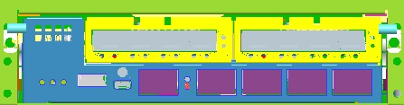
LED indicator on CTRL | Please refer to ES_LED_FP_v1.22 or later version for detailed LED definitions  Ctrl 1 LED in green/Amber, for Controller Status  Ctrl 2 LED in amber, for Cache Dirty status  Note : FBM : Flash Backup Module  Ctrl 3 LED in green, Fast Blink for Host Busy  Restore Default Button: LED in GREEN, the default of NVRAM is restored  Management Port *1 (1 in 1 connector): Speed LED on RJ-45 in green for 1G and blank for 10/100, Active LED Blink for LAN is active  iSCSI 1G *4 ports (1 in 1 connector): Speed LED on 4x RJ-45 in green for 1G and blank for 10/100, Active LED Blink for LAN is active
  Steady on | 1. Cache Memory is dirty or  2. Flushing data from FBM to drive (when power back)
  Blink | Writing cached data from cache memory to FBM* during power outage. Once writing is done, all LEDs are turned off.
  Off | No data is in cache memory
Connectors of rear-side of Host Boards of a single CTRL | For iSCSI 1G  4* iSCSI 1G cages provide 1G connectivity to HST  For iSCSI 10G (RJ45)  2* iSCSI 10G cages provide 10G/1G/100Mconnectivity to HST  For iSCSI 10G (SFP+)  2* iSCSI 10G cages provide 10G connectivity to HST– (2 on each Host board)  For SAS 12G (same for SAS 12G for JBOD Expansions)  2* SAS 12G cages provide 12/6/3G connectivity to HST– (2 on each Host board)  For FCoE (4 in 1)  4* SFP+ cages provide FC 8G x 4 or FC 16G x 2 or iSCSI 10G SFP+ x 4 connectivity to HST– (4 on each Host board)  For FC 16G x 2  2* FC 16G cages provide 16/8/4G connectivity to HST– (2 on each Host board)  InfiniBand 56G (FDR) x2  2* InfiniBand 56G connectivity to HST– (2 on each Host board)  For FC16G x4  4* SFP+ cages provide FC16G x 4 or FC 8G x 2 or FC4G x 4 connectivity to HST– (4 on each Host board)  Ethernet 40G Host Board x2  2* 40G connectivity to HST– (2 on each Host board)
LED indicator on Optional Host Boards | iSCSI 1G x4 ports Host Board LED  8 x GbE LEDs (two on each GbE port) to indicate the speed/ link status  For Speed LED:  For Link LED:  ------------------------------------------------------------------------------------------------------------------------  iSCSI 10G (RJ45) x2 ports Host Board LED  4 x GbE LEDs (two on each GbE port) to indicate the speed/ link status  For Speed LED:  For link status LED:  -----------------------------------------------------------------------------------------------------------------------------  iSCSI 10G (SFP+) Host Board LED  1* CH0 LED in green, for CH0 link status  1* CH1 LED in green, Steady On for CH1 link: spec is same as CH0 LED.  ----------------------------------------------------------------------------------------------------------------------------  SAS 12G x2 ports Host Board LED (Same for SAS 12G host board support JBOD expansions)  2* LEDs (one for each host port), to indicate link status  For Link status LED:  ----------------------------------------------------------------------------------------------------------------------------  4 in 1 Host x4ports Board LED  8* LEDs (2 for each host port), to indicate link / speed status  2* Mode LEDs, to indicate mode status  For Mode LED:  For Link status LED:  For Speed LED (16G Fiber mode):  For Speed LED (8G Fiber mode):  For Speed LED (10G Ethernet mode):  --------------------------------------------------------------------------------------------------------------------------------  FC 16G x 2 Host Board LED  2* CH0/1 LEDs, to indicate CH0 link / speed status  Link status LED: LED in Green for Link, and off for unlink  Speed status LED:  1* CH0 LED in green, for CH0 link status  ---------------------------------------------------------------------------------------------------------------------------------  FC16G x 4 Host Board LED  Each channel has three LED to indicate different speed as below showed.  ------------------------------------------------------------------------------------------------------------------------------------------------  Ethernet 40G Host Board LED  2* CH0/1 LEDs, to indicate CH0 link / speed status  Link status LED: LED in Green for Link, and off for unlink  Speed status LED:
   | CH4/CH8 | CH5/CH9 | CH6/CH10 | CH7/CH11
  LED on | 1G | 1G | 1G | 1G
  LED off | 10/100Mbps | 10/100Mbps | 10/100Mbps | 10/100Mbps
   | CH4/CH8 | CH5/CH9 | CH6/CH10 | CH7/CH11
  Steady on | Link | Link | Link | Link
  Blink | Active | Active | Active | Active
  Off | No link | No link | No link | No link
   | CH4/CH8 | CH5/CH9
  Green | 10G | 10G
  Amber | 1G | 1G
  LED off | 100Mbps | 100Mbps
   | CH4/CH8 | CH5/CH9
  Steady on | Link | Link
  Blink | Active | Active
  Off | No link | No link
  Steady on | Link
  Blink | Active
  Off | No link
   | CH4/CH8 | CH5/CH9
  Steady on | Link | Link
  Blink | Active | Active
  Off | No link | No link
  16G/8G - Green | 16G Fiber mode  (only 2 ports can support this mode)
  16G/8G - Amber | 8G Fiber mode
  10G - Green | 10G Ethernet mode
   | CH4/CH8 | CH5/CH9 | CH6/CH10 | CH7/CH11
  Green | Link | Link | Link | Link
  Off | No link | No link | No link | No link
   | CH4/CH8 | CH5/CH9 | CH6/CH10 | CH7/CH11
  Green | 16G | 16G
  Amber | 8G | 8G
  Off | 4G or no link | 4G or no link
   | CH4/CH8 | CH5/CH9 | CH6/CH10 | CH7/CH11
  Green | 8G | 8G | 8G | 8G
  Amber | 4G | 4G | 4G | 4G
  Off | 2G or no link | 2G or no link | 2G or no link | 2G or no link
   | CH4/CH8 | CH5/CH9 | CH6/CH10 | CH7/CH11
  Green | 10G | 10G | 10G | 10G
  Amber
  Off | No link | No link | No link | No link
  Green | 16G
  Amber | 8G
  LED off | 4G
  Steady on | Link
  Blink | Active
  Off | No link
  For 16G Speed LED:
   | CH0 | CH1 | CH2 | CH3
  Green on | Linked
  Green Blinking | Data Transfer
  LED off | No connect
  For 8G Speed LED:
   | CH0 | CH1 | CH2 | CH3
  Green on | Linked
  Green Blinking | Data Transfer
  LED off | No connect
  For 4G Speed LED:
   | CH0 | CH1 | CH2 | CH3
  Amber on | Linked
  Amber Blinking | Data Transfer
  LED off | No connect
  Green | Link
  Amber | Active
  LED off | Not connected
Section 3：CTRL PCBA and Host Board PCBA requirement
Category | Functional Specification | Remark
2U8:  RAID engine G Models CTRL PCBA (3841GSP08E) | For GSe Pro 3008 Models CTRL :  For 2U8 serial RAID engines CTRL use the same PCBA (PCBA named as 3841GSP08E)
RAID engine Host Boards: | For RAID engine Host Boards :  - iSCSI 1G 4 ports host boards 9483CE1HIO4  - iSCSI 10G (SFP+) 2 ports host boards 9483CE1HIO2  - iSCSI 10G (RJ45) 2 ports host boards 9483CE2HIO2  - SAS 12G 2 ports host boards 9483CS2HIO2  - 4 in 1, 4 ports host boards 9483CC1HIO4  - FC16G 2 ports host boards 9483CF9HIO2  - FC16G 4 ports host boards 9483CF9HIO4  - Infiniband 2 ports host boards 9483CE3HIO2  - iSCSI 40G 2 ports host boards 9576CE4HIO2  - SAS 12G 2 ports for JBOD Expansions host boards 9483CSJHIO2
DRV backplanes | Different products use different Base-units w/ DRV BP PCBAs. And naming are listed as below:  Note 1.  - D means EonStor DS,  - x=0 means no bundle HDD and x=P means half qty of bundle HDD (8 for 3U, and 6 for 2U)  Please refer to ESS16F-X1840_FTS_V1.0 or later version for detail spec  Please refer to \\Server02\pm\PCC infor system\A667_models_naming for Enclosure/PCBA naming
  F/F | G/R | Base-unit | DRV BP PCB | DRV BP PCBA | Models
  2U8 | G | ESS12G2B2Dx-0035 | 9583ADP08G | 9583ADP08G | GSe Pro 3008
Other small boards: | - Power board: 9583PWR2U  2U height, redundant PSU design.  - Adaptor board: 9583ADP  To access Power board and Backplane.
Cache Backup Module for Caching Data | R CTRLs are having Cache Backup Module for default. G CTRLs are option.
FW feature spec | Use FW v3.91 or later version (follow EonStor G6)
SW feature spec | Use SW v2.3.x or later version (follow EonStor G6)
Appendix 1: CTRL Key parts and general information of each model
Controller | DS RAID CTRL
3841GSP08E | GSe Pro 3008
Host Boards | DS RAID Host Board
iSCSI 1G 4 ports host boards 9483CE1HIO4 | GSe Pro 3008
iSCSI 10G (SFP+) 2 ports host boards 9483CE1HIO2 | GSe Pro 3008
iSCSI 10G (RJ45) 2 ports host boards 9483CE2HIO2 | GSe Pro 3008
SAS 12G 2 ports host boards 9483CS2HIO2 | GSe Pro 3008
4 in 1, 4 ports host boards 9483CC1HIO4 | GSe Pro 3008
FC16G 2 ports host boards 9483CF9HIO2 | GSe Pro 3008
FC16G 4 ports host boards 9483CF9HIO4 | GSe Pro 3008
Infiniband 2 ports host boards 9483CE3HIO2 | GSe Pro 3008
iSCSI 40G 2 ports host boards 9576CE4HIO2 | GSe Pro 3008
SAS 12G 2 ports host boards 9483CSJHIO2
Memory module per CTRL
DDR4 RDIMM 4GB | Default, 4GB*1
DDR4 RDIMM 8GB | Optional, 4GB*2
DDR4 RDIMM 16GB | Optional, 8GB*2
DDR4 RDIMM 32GB | Optional, 16GB*2
DDR4 RDIMM 64GB | Optional maximum, 32GB*2
Appendix 2: Spare parts and Accessories
CTRL FRU P/N | GSe Pro 3008
3841GSP08E | V

GSe Pro 3000 Series
BP FRU P/N |  | GSe Pro 3008
9583ADP08G |  | V
Host Board FRU P/N |  | GSe Pro 3008
iSCSI 10G SFP+ (RES10G1HIO2-0010) |  | Y
iSCSI 10G RJ45 (RES10G1HIO2-0010) |  | Y
SAS12G (RSS12G1HIO2-0010) |  | Y
4 in 1 (RFE16G1HIO4-0010) |  | Y
iSCSI 1G RJ45 (RER01G1HIO4-0010) |  | Y
FC16G x 2 (RFC16G1HIO2-0010) |  | Y
FC16G x 4 (RFC16G1HIO4-0010) |  | Y
iSCSI 40G x 2 (RER40G1HIO2-0010) |  | Y
SAS12G (RSS12J1HIO2-0010) |  | Y
Level-1 | Level-2 |  | FRU P/N | GSe Pro 3008
Cables | FC |  | 9270CFCCab04-0010 | Y
Cables |  |  | 9270CFCCab05-0010 | Y
Cables |  |  | 9270CFCCab06-0010 | Y
Cables | Mini SAS 4X(SFF-8088) to Mini SAS 4X(SFF-8088) |  | 9270CmSASCab1-0030 (0.5M) | Y
Cables |  |  | 9270CmSASCab2-0030 (1.2M) | Y
Cables |  |  | 9270CmSASCab6-0030 (1.7M) | Y
Cables |  |  | 9270CmSASCab7-0030 (2.6M) | Y
Cables | SAS 12G Cables |  | 9370CmSASCab1-0030 (0.5M) | Y
Cables |  |  | 9370CmSASCab2-0030 (1.2M) | Y
Cables |  |  | 9370CmSASCab3-0030 (2.6M) | Y
Cables | Mini USB Cable |  | 9370ASCAB-0010 | Y
SFP module | 8G |  | 9370CSFP8G-0010 | Y
SFP module | 10G |  | 9370CSFP10G-0010 | Y
SFP module | 16G |  | 9370CSFP16G-0010 | Y

2. Enclosure FRU
Level-1 | FRU P/N | GSe Pro 3008
PSU | 9583CPSU-0010 | Y
Slide Rail | 9571CSLIDER-0010 | Y
Ear Rail | 9571CEAR-0010 | Y

Appendix 5: Content of Accessory Box (for ref.)
For GSe Pro 3008 series models
- One GUI CD pack, HW manual and operation manual inside
- One EonOne CD pack
- Two power cords
- One mini-USB to DB-9 cable
- 40 screws for HDD installation
- 16 screws for mounting enclosure to rack（M6 x4 and M5 x4 and #10-32 x4）

Models | GSe Pro 3008 series + Optional Host Boards
CPU | Intel CPU Broadwell-DE D-1517 (3841GSP08E)
RAID ENGINE | CPU/SW RAID
Memory socket | DDR4 x 2 sockets
DIMMs | 4GB RDIMM x 1 (default)
DIMMs | (MAX 64GB per CTRL)
Flash ROM | 16M x 2
NVRAM | FRAM FM21L16 (2Mbit)
Flash Backup Module | m.2 64G MLC Flash
Configuration LAN chip | Broadwell-DE + Intel i218
Configuration LAN port | RJ45 w/ 2 LED x 1 (phy)
On Board LAN (1G) | RJ45 w/ 2 LED x 4 (i210)
M.2 connector | Yes x 1
RS232 port | min USB
USB 3.0 | x1
LED indicator | - Controller status
LED indicator | - CBM status
LED indicator | - Cache Dirty Status
LED indicator | - Host busy
LED indicator | - LAN Link
LED indicator | - LAN Active
LED indicator | - Restore Def
LED indicator | - 4*CH0 Link / Speed status (iSCSI 1G)
LED indicator | - 4*CH1 Link / Speed status (iSCSI 1G)
Push button | Yes (HW reserve only)
LCD/ LED PNL | LED support only
Buzzer | Yes
Driver Interface | SATA only
Drive chip | (1) Marvell 9235*1
Drive chip | (2) Integrated SATA 6G port
Drive channel allocation | Please check the Block Diagram for details
Connector to BP | (1 x 5*6 pin connector + 2 x 9*6 pin “4 wall” Airmax)
I2C interface | YES
PCBA | 3841GSP08E + Optional Host Boards

Architecture for system block diagram

For GSe Pro 3008 series

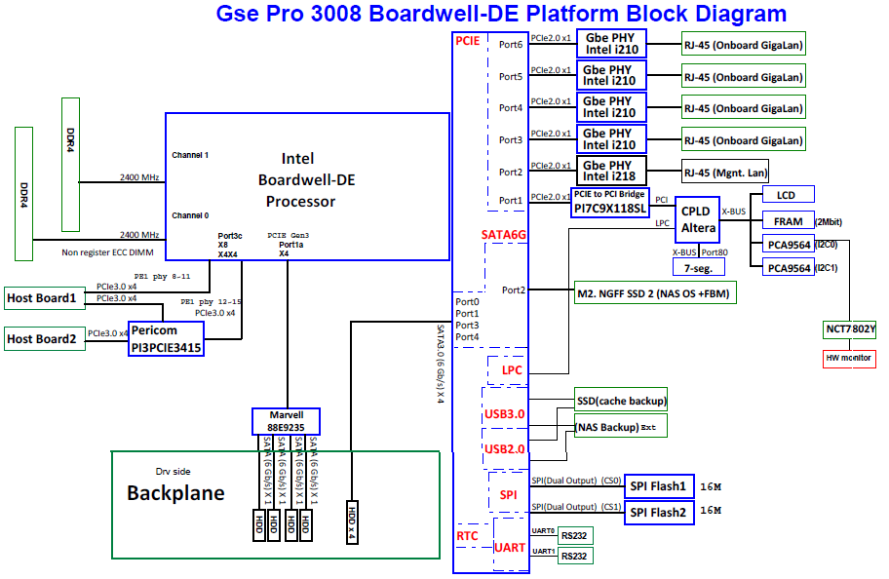
ME Drawing
- Front view
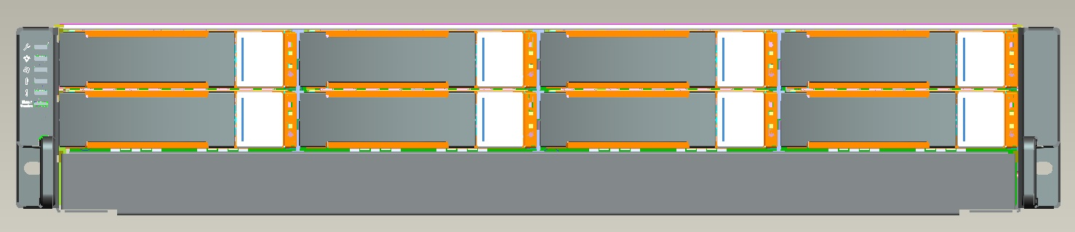

- Rear view
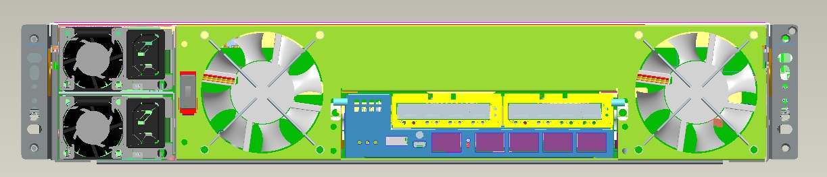

- System
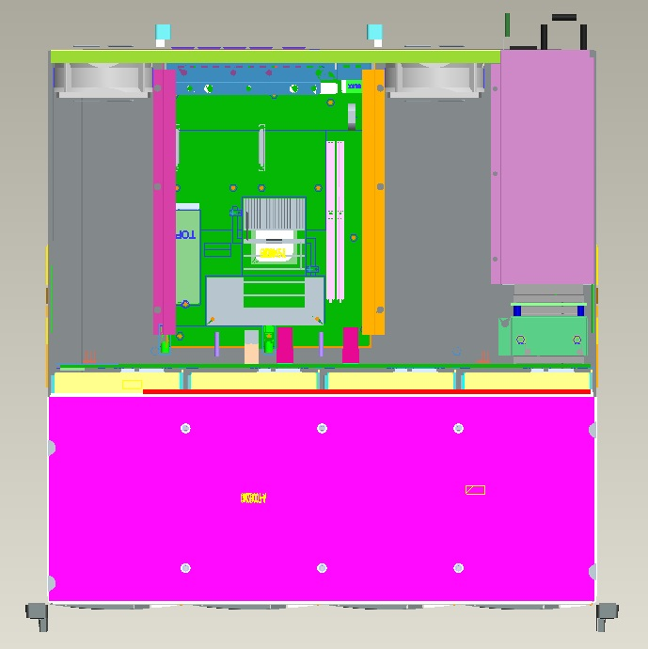

- CTRL
