PROJECT NAME： GSe Pro 1000 series |  |  |  |  |  |  |  |  | Rev.：1.0
DESCRIPTION: (ref):
GSe Pro 1004 series
1U4-bay RAID subsystem, Generic controller, SATA2, Intel Avoton C2538

GSe Pro 1008 series
2U/8-bay RAID subsystem, Generic controller, SATA2, Intel Avoton C2538

PRODUCT MANAGER：Glenn.Lee |  |  |  |  | DATE：2017/06/06
MODEL NAME / NUMBER :
Gse Pro 1000 serial models
Gse Pro 1004 + no optional host boards

Gse Pro 1008 + no optional host boards

APPROVED：
FW PM HW TM FW TM ME TM SW TM
PROJECT ORIGINATOR |  |  |  |  | PM MANAGER
NOTIFY：
SALE |  | SOFTWARE | HARDWARE | MFG. MGR. |  | GEN.MGR.

Change History List
Rev | Update Reason |  |  |  |  |  | Updated Date |  |  | Updated By |  | Approved By
1.0 | New Release |  |  |  |  |  | 2017/06/06 |  |  | Glenn.Lee

Section 1: Overall view for whole product
Category | Functional Specification | Remark
Innovation | First IFT cloud gateway product
EonStor serial models products definition | Per C0 spec., EonStor GS serial models are:  - GSe Pro 1004  - GSe Pro 1008  EonStor FS C0 MKT document:  - \\server02\Marketing\Product Planning\C0\Unify storage\Cloud Gateway  HDD Bundle policy:  - Any number of "Drive + Plastic Tray"  - HDD types and q’ty are defined by Planning  Cloud Gateway Product feature:  Please follow the latest GS product feature:  Host Board Support types:  No host board design  GSe Pro 1000 series Performance requirement:  GSe Pro 1000 series JBOD Support Models and Max Drive Policy:  N/A
  Product Family | GSe Pro 1000
  CPU | Avoton C2538
  Drive side interface | SATA 6G
  GSe File read (MB/s) | 400
  GSe File write (MB/s) | 400
DIMM Configuration Requirements | Default configuration: 4GBx1  Support DDR3 up to 32G (16Gx2)  Optional configurations: 8G (4G x2), 16G (8Gx2), 32G (16Gx2)
Super Cap  and SSD requirements | No Super Cap.
Push button requirement | For Reset CTRL to Restore default Status
LCD and LED Requirements | Only support LED PNL; HW design reserve LCD  LED follows ES_LED_FP_v1.22 or later version
HDD Support requirements | Support mixing SATA 3G/6G drives on AVL  Support SATA-SSD (SSD: follow HDD AVL plan)
Form-factor requirements | Follow Enhance 3US and 2US ME design.
RoHS requirement | RoHS complaint is a MUST from development stage
PSU Requirements | For 2U12/3U16 platform: 3Y-460W
  RAID Form-factor | Enclosure Name | Controller | PSU | Vendor
  1U4 | 1Ux | Generic | 250 Watt | Delta
  2U8 | 2Ux | Generic | 250 Watt | Delta
Patent Concern | N.A.
MTBF | Controller: 500,000 hours  Subsystem: 25,000 hours  Power supplies: 250,000 hours  Fans: 500,000 hours
EMC / Safety | Certification product names: should follow IFT business method of CTO  EMC: BSMI, FCC / CE Class A (Class A is Acceptable).  Safety: UL / cUL, CB, and ROSTEST (Russia Certificate)
Env. | Thermal: System working temperature should follow specs.  - Normal Operating: The temperature should be below 40C.  - Abnormal Operating (FANx1 or PSUx1 Failure): The temperature should remain below 40C  - Due to CPU spec, it cannot operate below 5C. Please test the system above 5C or equal to 5C to meet the CPU spec.  - Thermal concern Super Cap the Spec of Super cap is -25C~60C, Therefore it is recommend that w/o Super cap installed the room temperature cannot over 40C and W super cap installed the room temperature cannot over 40C.
Interoperability Req. | Refer to TD-4-06 Interoperability Test item of later version for SxF
Section 2: User interface and customer related information
Category | Functional Specification | Remark
Connectors of rear-side of CTRL | For Single CTRL  - 1* mini USB connectors provide COM1 connectivity to HST.  - 4* RJ-45 connectors (1 in 1) provide 1GB (Management?) function – on Main board  - 2* USB 2.0 connector – on Main board  - 2* USB 3.0 connector – on Main board
CTRL Drawing | 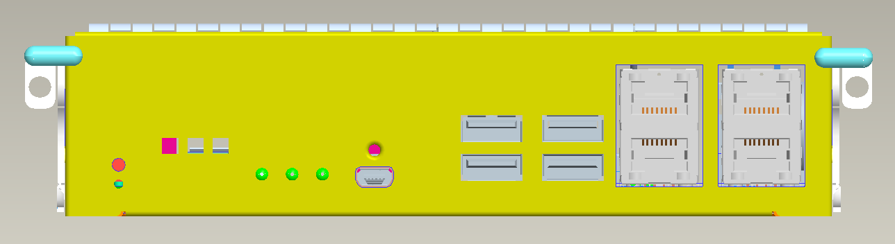
LED indicator on CTRL | Please refer to ES_LED_FP_v1.22 or later version for detailed LED definitions  Ctrl 1 LED in green/Amber, for Controller Status  Ctrl 2 LED in amber, for Cache Dirty status  Note : FBM : Flash Backup Module  Ctrl 3 LEDs in green/amber to indicate CBM* Status  Note : CBM: Cashe Backup Module  Ctrl 4 LED in green, Fast Blink for Host Busy  Restore Default Button: LED in GREEN, the default of NVRAM is restored  Management Port *1 (1 in 1 connector): Speed LED on RJ-45 in green for 1G and blank for 10/100, Active LED Blink for LAN is active  iSCSI 1G *4 ports (1 in 1 connector): Speed LED on 4x RJ-45 in green for 1G and blank for 10/100, Active LED Blink for LAN is active
  Steady on | 1. Cache Memory is dirty or  2. Flushing data from FBM to drive (when power back)
  Blink | Writing cached data from cache memory to FBM* during power outage. Once writing is done, all LEDs are turned off.
  Off | No data is in cache memory
  Steady on in Green | CBM is ready which means BBU (Super Cap.) and SSD Card both are present
  Blink in Green | BBU (Super Cap.) is charging
  Steady on in Amber | 1. BBU (Super Cap.) or SSD Card or both failed  2. No BBU (Super Cap.) and/or SSD Card are found in Redundant models.
  Off | BBU (Super Cap.) is not installed in Generic Models
Section 3：CTRL PCBA and Host Board PCBA requirement
Category | Functional Specification | Remark
1U4/2U8:  RAID engine G Models CTRL PCBA (3822GSP04E  and 3822GSP08E) | For GSe Pro 1004 Models CTRL :  For 2U/3U serial RAID engines CTRL use the same PCBA (PCBA named as 3822GSP04E)  For GSe Pro 1008 Models CTRL :  For 2U/3U serial RAID engines CTRL use the same PCBA (PCBA named as 3822GSP08E)  The design needs to keep the flexibility.
DRV backplanes | Different products use different Base-units w/ DRV BP PCBAs. And naming are listed as below:  Note 1.  - D means EonStor DS,  - x=0 means no bundle HDD and x=P means half qty of bundle HDD (8 for 3U, and 6 for 2U)  Please refer to ESS16F-X1840_FTS_V1.0 or later version for detail spec  Please refer to \\Server02\pm\PCC infor system\A667_models_naming for Enclosure/PCBA naming
  F/F | G/R | Base-unit | DRV BP PCB | DRV BP PCBA | Models
  1U4 | G | ESS04G2B2Dx-0035 | 9583ADP04G | 9583ADP04G | GSe Pro 1004
  2U8 | G | ESS08G2B2Dx-0035 | 9583ADP08G | 9583ADP08G | GSe Pro 1008
1U4: other small boards | - Power board: 9583PWR1U  1U height, redundant PSU design.
2U8: Other small boards | - Power board: 9583PWR2U  2U height, redundant PSU design.  - Adaptor board: 9583ADP  To access Power board and Backplane.
Cache Backup Module for Caching Data | R CTRLs are having Cache Backup Module for default. G CTRLs are option.
FW feature spec | Use FW v3.91 or later version (follow EonStor G6)
SW feature spec | Use SW v2.3.x or later version (follow EonStor G6)
Appendix 1: CTRL Key parts and general information of each model
Controller | DS RAID CTRL
3822GSP04E | GSe Pro 1004
3822GSP08E | GSe Pro 1008
Memory module per CTRL
DDRIII 4GB | Default, 4GB*1
DDRIII 8GB | Optional, 4GB*2
DDRIII 16GB | Optional, 8GB*2
DDRIII 32GB | Optional, 16GB*2
Appendix 2: Spare parts and Accessories
CTRL FRU P/N | GSe Pro 1004 | GSe Pro 1008
3822GSP04E | V
3822GSP08E |  | V

GSe Pro 1000 Series
BP FRU P/N |  | GSe Pro 1004 |  | GSe Pro 1008
9583ADP04G |  | V
9583ADP08G |  |  |  | V
Level-1 | Level-2 |  | FRU P/N |  | GSe Pro 1000
Cables | Mini USB Cable |  | 9370ASCAB-0010 |  | Y

2. Enclosure FRU
Level-1 | FRU P/N | GSe Pro 1000
PSU | 9583CPSU-0010 | Y
Slide Rail | 9571CSLIDER-0010 | Y
Ear Rail | 9571CEAR-0010 | Y

Appendix 5: Content of Accessory Box (for ref.)
For GSe Pro 1004 series models
- One GUI CD pack, HW manual and operation manual inside
- One EonOne CD pack
- Two power cords
- One mini-USB to DB-9 cable
- 20 screws for HDD installation
- 16 screws for mounting enclosure to rack（M6 x4 and M5 x4 and #10-32 x4）

For GSe Pro 1008 series models
- One GUI CD pack, HW manual and operation manual inside
- One EonOne CD pack
- Two power cords
- One mini-USB to DB-9 cable
- 40 screws for HDD installation
- 16 screws for mounting enclosure to rack（M6 x4 and M5 x4 and #10-32 x4）

Models | GSe Pro 1000 series
CPU | Intel CPU Avoton C2538
RAID ENGINE | CPU/SW RAID
Memory socket | DDR3 x 2 sockets
DIMMs | 4GB DIMM x 1 (default)
DIMMs | (MAX 32GB per CTRL)
Flash ROM | 16M x 2
NVRAM | FRAM FM21L16 (2Mbit)
Flash Module | m.2 64G MLC Flash
On Board LAN (1G) | RJ45 w/ 2 LED x 4 (88E1543)
M.2 connector | Yes x 1
RS232 port | min USB
USB 2.0 | x2
USB 3.0 | x2
LED indicator | - Controller status
LED indicator | - CBM status
LED indicator | - Cache Dirty Status
LED indicator | - Host busy
LED indicator | - LAN Link
LED indicator | - LAN Active
LED indicator | - Restore Def
LED indicator | - 4*CH0 Link / Speed status (iSCSI 1G)
LED indicator | - 4*CH1 Link / Speed status (iSCSI 1G)
Push button | Yes (HW reserve only)
LCD/ LED PNL | LED support only
Buzzer | Yes
Driver Interface | SATA only
Drive chip | (1) Marvell 9235*1 (for GSe Pro 1008)
Drive chip | (2) Integrated SATA 3G port
Drive channel allocation | Please check the Block Diagram for details
Connector to BP | GSe Pro 1004: (1 x 5*6 pin connector + 1 x 9*6 pin “4 wall” Airmax)  GSe Pro 1008: (1 x 5*6 pin connector + 2 x 9*6 pin “4 wall” Airmax)
I2C interface | YES
PCBA | 3822GSP04E (GSe Pro 1004)  3822GSP08E (GSe Pro 1008)
Architecture for system block diagram
For GSe Pro 1004 series
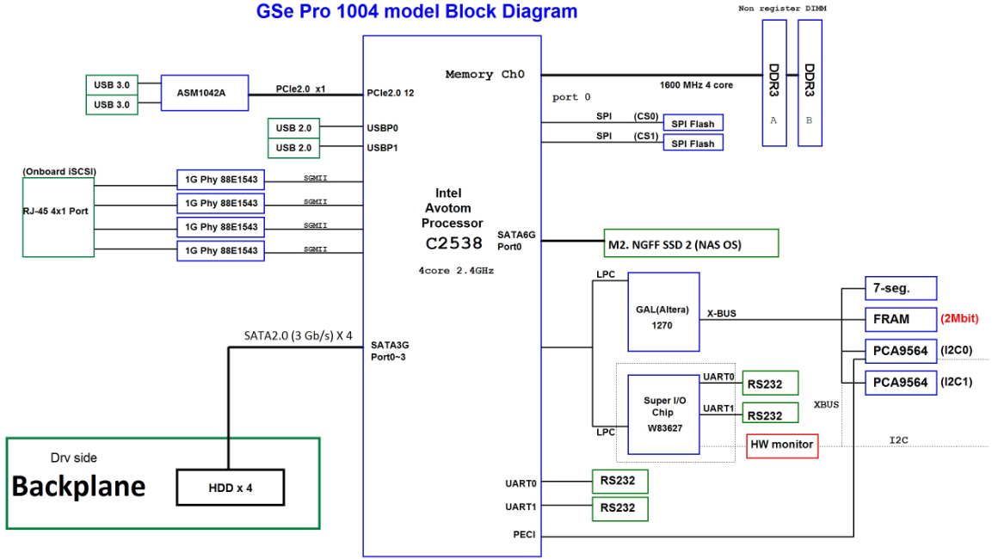
GSe Pro 1008 series
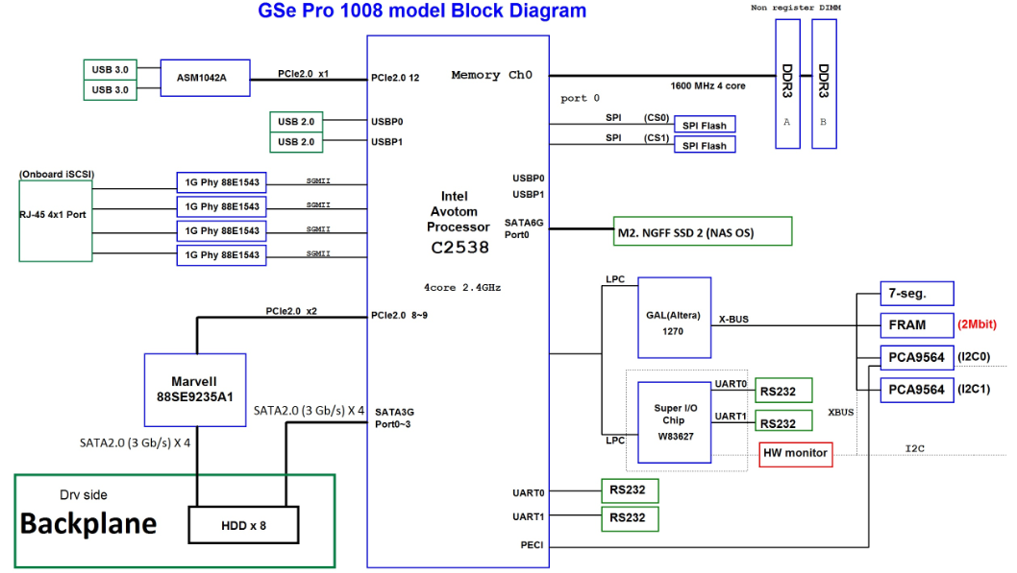
ME Drawing
- Front view
1U4
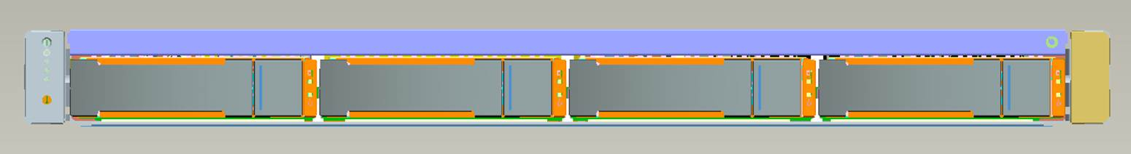

2U8
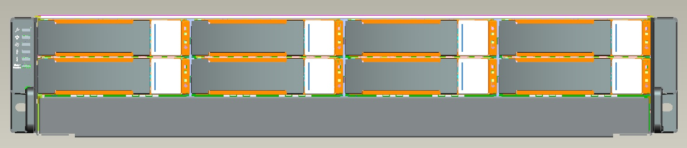

- Rear view
1U4
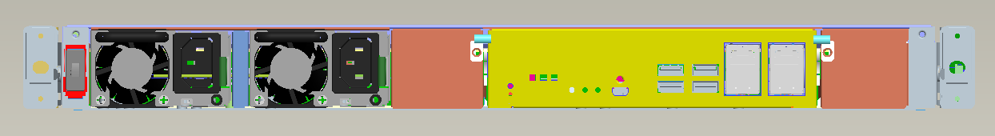

2U8
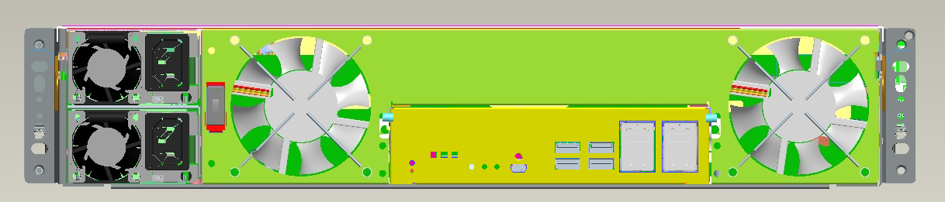

- System
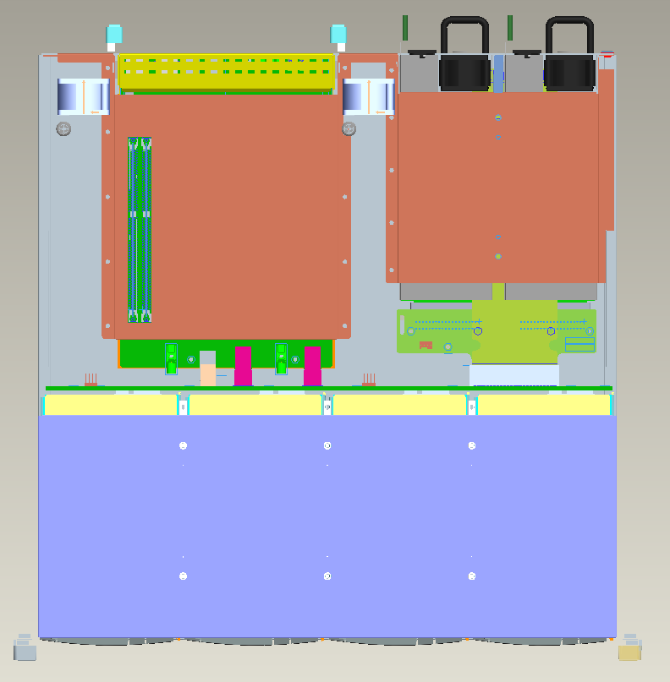
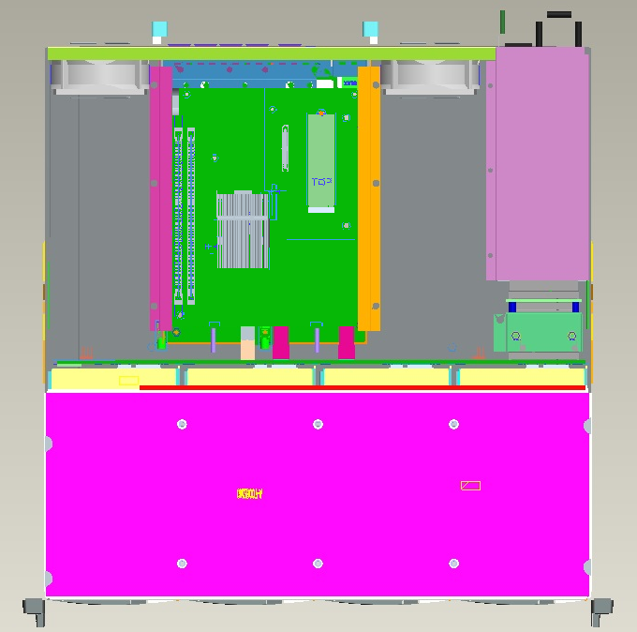
CTRL
